Docker Task -3

Create a custom docker image for nginx and deploy it using docker compose, where the volume bind mount should be at /var/opt/nginx location. Push the created custom docker image to your docker-hub.
1.Create Project Structure
# mkdir custom-nginx
# cd custom-nginx
# touch Dockerfile docker-compose.yml
2. Create Custom HTML Page
# nano html/index.html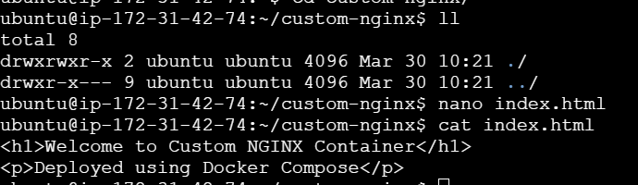

3. Create Dockerfile
# nano Dockerfile
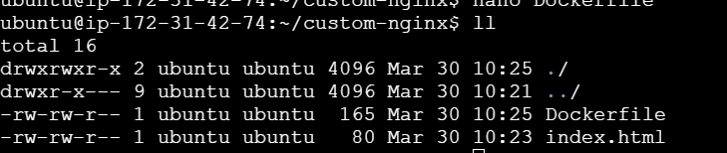
4. Build Docker Image
# docker build -t custom-image/custom-nginx:v1 .
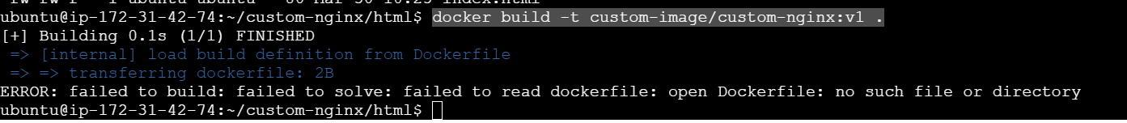
5. Login to Docker Hub
# docker login
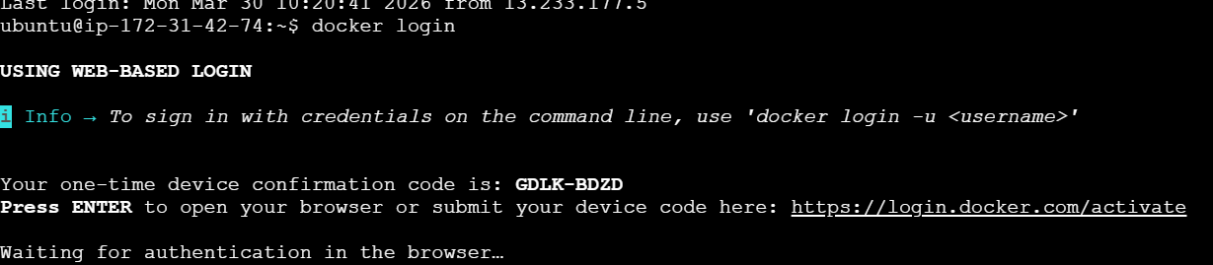
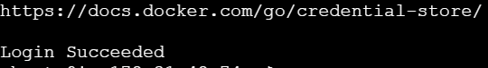

6. Push Image to Docker Hub
# docker push shanthidevi/custom-nginx:v1
7. Create Docker Compose File
nano docker-compose.yml
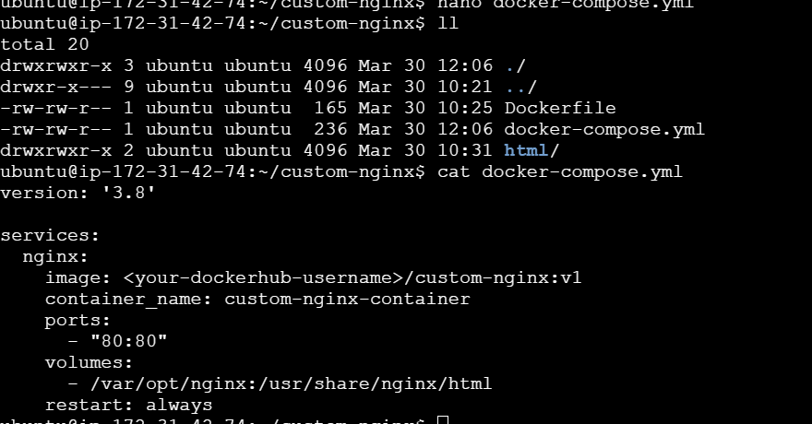

8. Prepare Bind Mount Directory
# echo '<h1>Bind Mount Working!</h1>' | sudo tee /var/opt/nginx/index.html
9. Run Docker Compose
# docker-compose up -d
10. Verify Output
Check the browser: http://13.206.69.209


